CS 255 System Design Document

UML Diagrams

UML Use Case Diagram
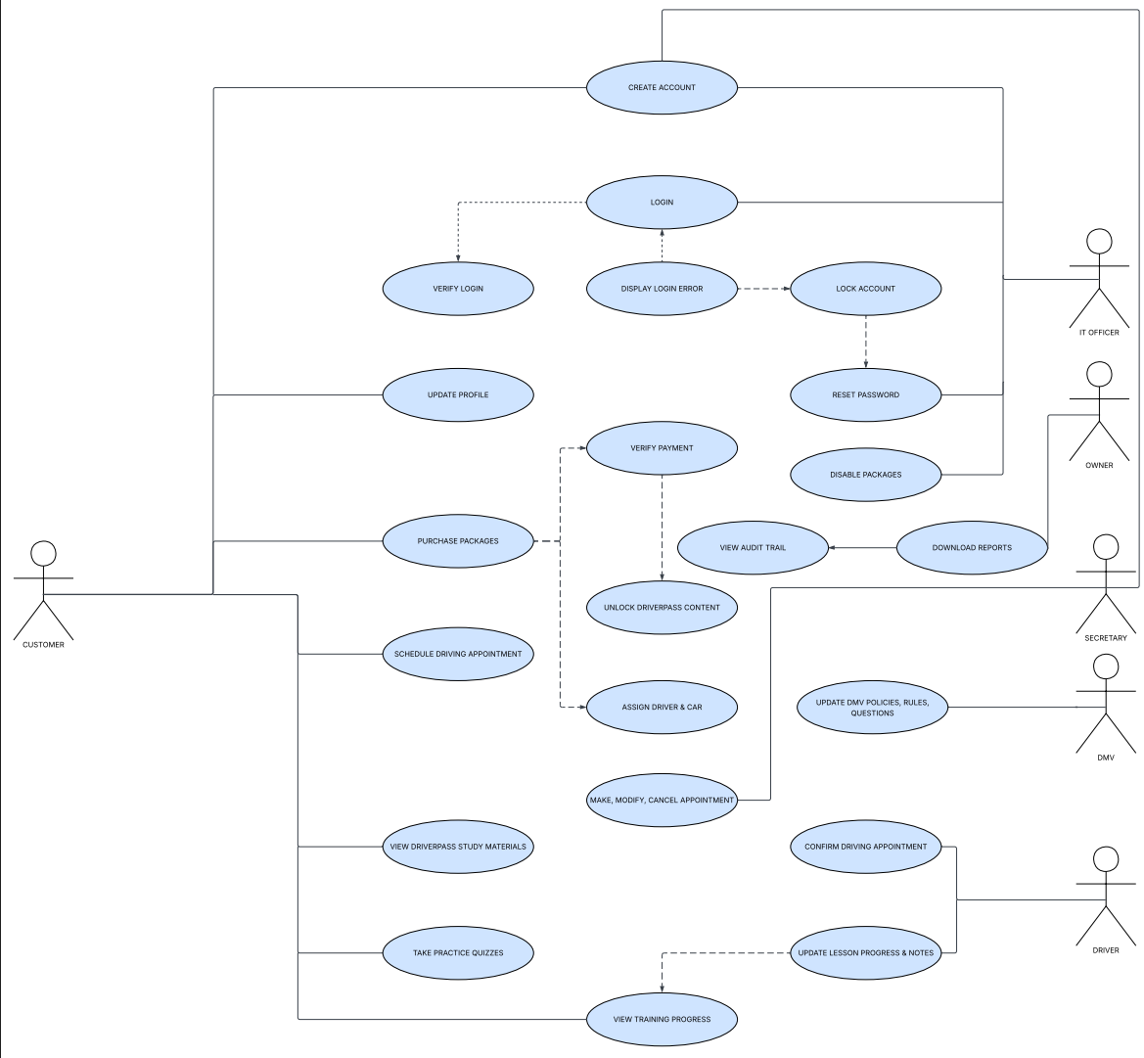

UML Activity Diagrams
Appointment Request Activity Diagram

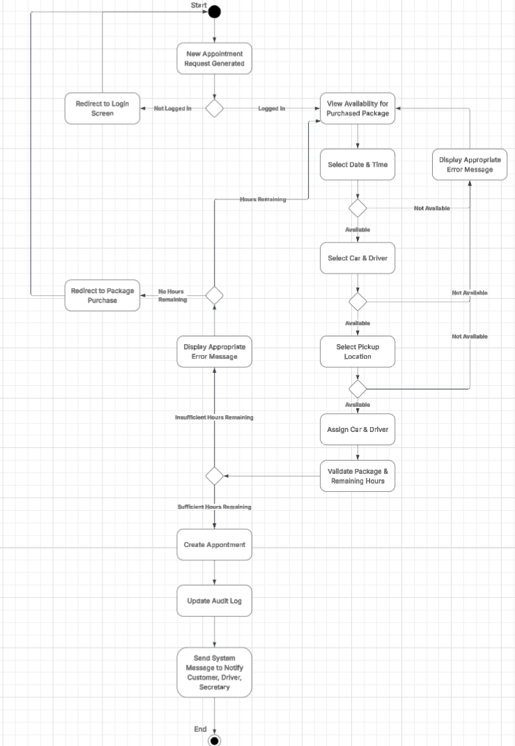

Login Activity Diagram

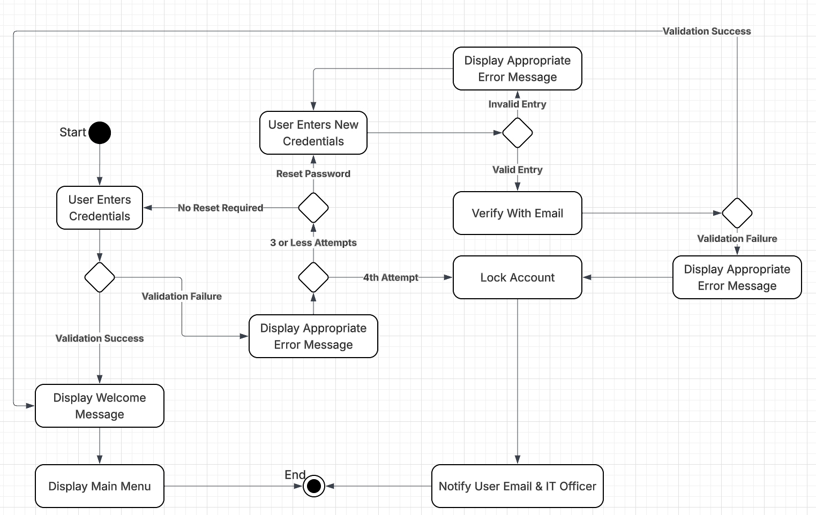

UML Sequence Diagram
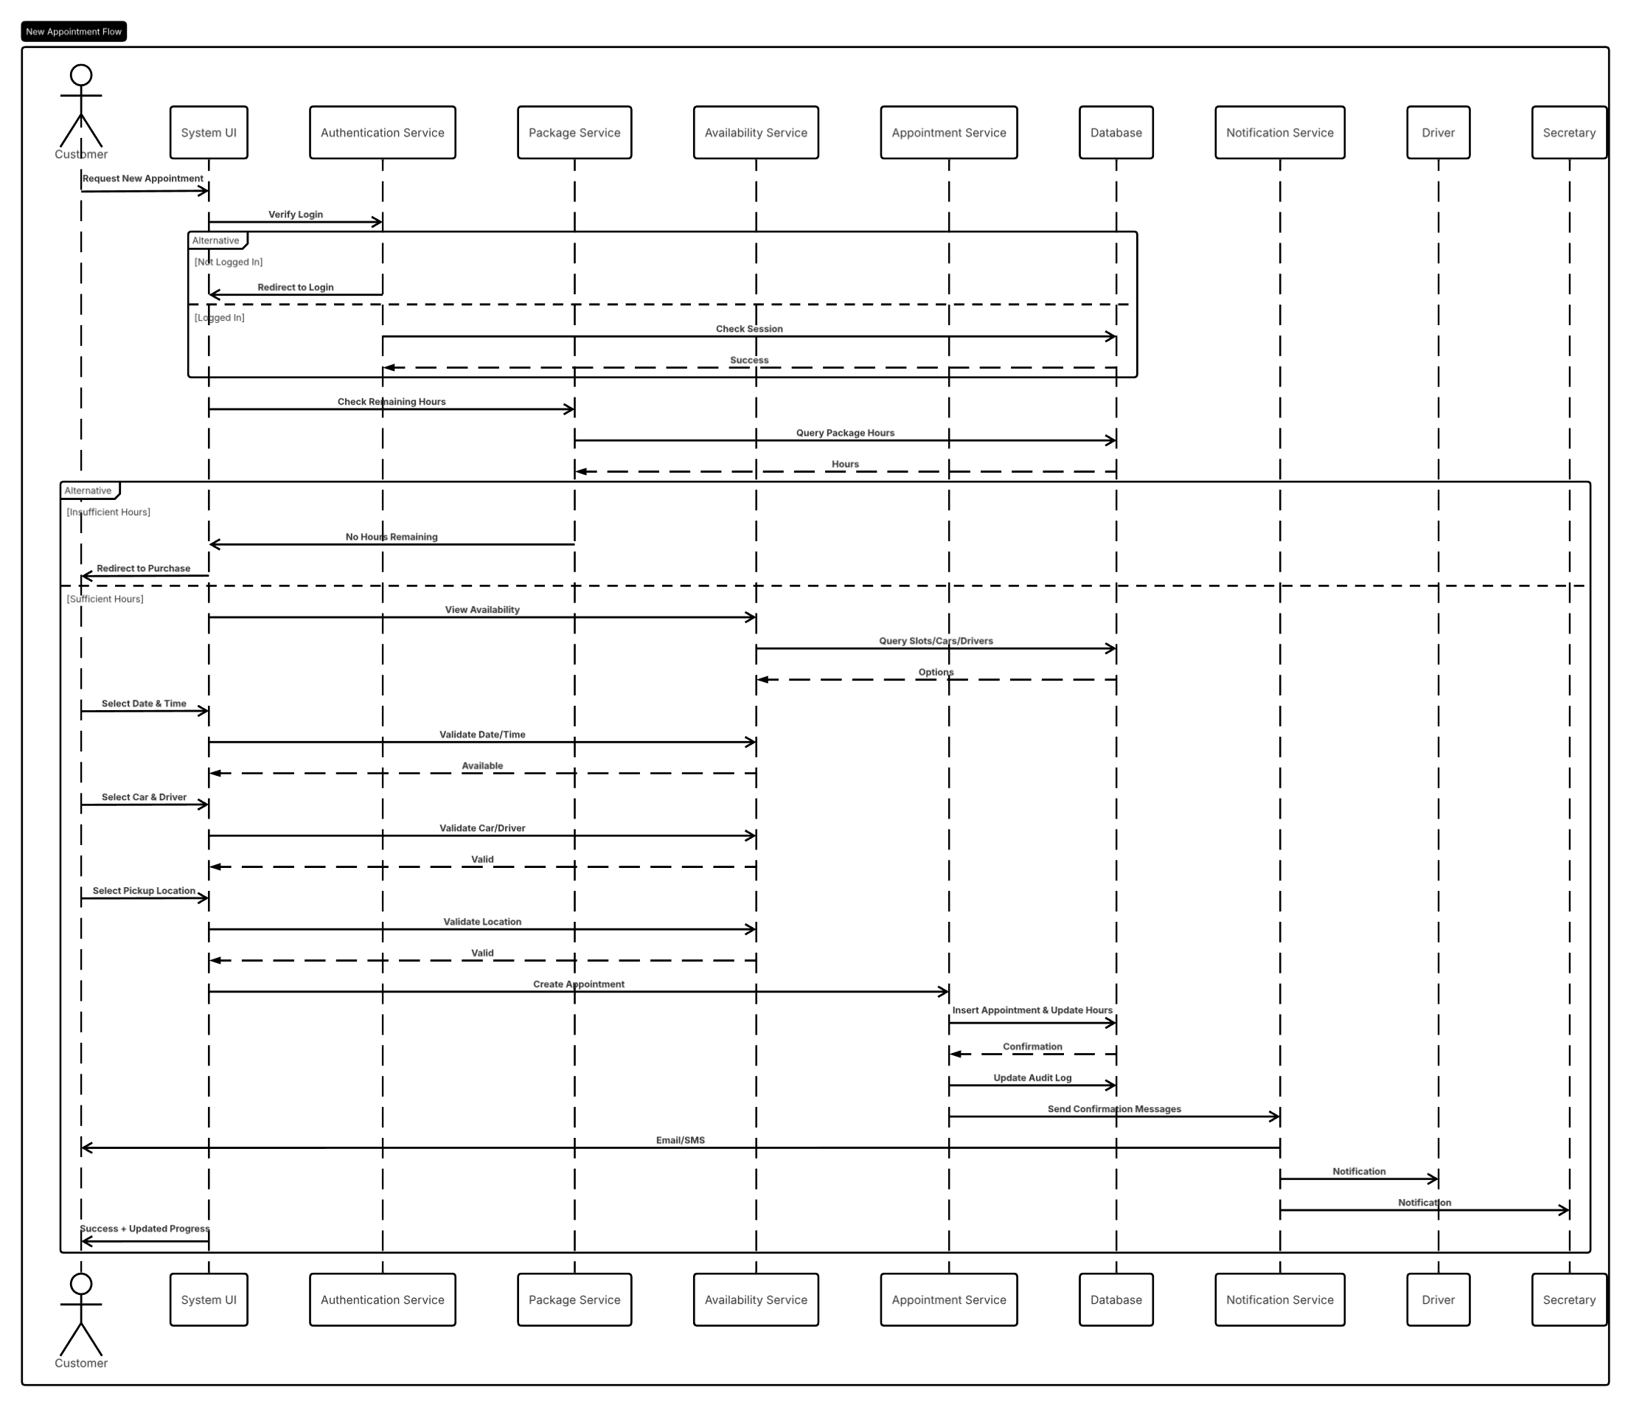

UML Class Diagram
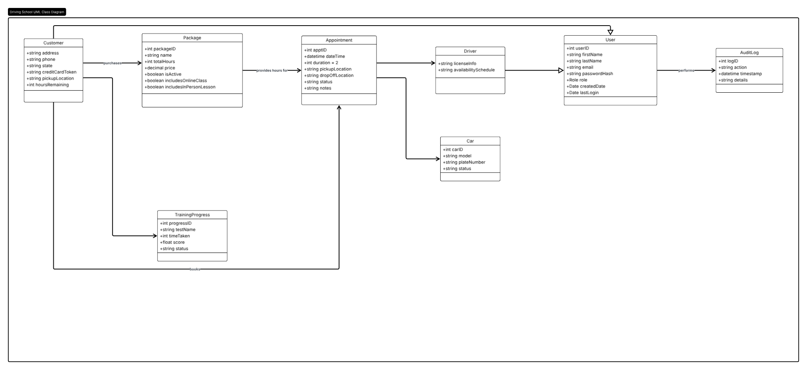

Technical Requirements

1. Hardware Requirements:
The system requires standard computer hardware for end users, including any modern desktop, laptop, tablet, or mobile device with internet access. Server-side hardware shall be provided through cloud infrastructure with sufficient processing power and memory to handle concurrent user interactions.

2. Software Requirements:
The system shall use HTML5, CSS3, and JavaScript for the frontend, Node.js/Express or .NET Core for the backend, and a relational database management system for data storage.

3. Tools:
Development will be done using industry-standard tools, including Visual Studio Code for coding, Lucidchart for UML diagrams, and MySQL Workbench for database management.

4. Infrastructure:
The system will be hosted on a cloud infrastructure, leveraging Amazon Web Services or Microsoft Azure to ensure scalability, availability, and automatic backups.

5. Integration Requirements:
The system will integrate with Stripe for secure payment processing, SendGrid or Twilio for email and SMS notifications, and a secure endpoint for DMV content updates.

6. Scalability and Performance:
The system should be designed to scale horizontally to accommodate a growing user base. Performance benchmarks should ensure that pages load within 2 seconds and appointment availability checks complete quickly.

7. Security Requirements:
User authentication should use secure login with password hashing. Role-based access control should be enforced. Data must be encrypted using HTTPS. An account lockout policy will be enforced after 4 failed login attempts. Full audit logging will track all reservation changes.

8. Compatibility Requirements:
The system must be compatible with Windows, macOS, iOS, and Android. It should be designed to work seamlessly on popular web browsers and mobile devices.

